**Project-Hand Gesture Recognition.**

**Index**

|  |  |  |  |
| --- | --- | --- | --- |
|  |  | **Title** | **Page no.** |
|  |  | Abstract | 5 |
|  |  | Contents | 6 |
| **Chapter 1** | **1** | Introduction | 7 |
| **Chapter 2** | **2** | Literature Review | 8-9 |
|  | 2.1 | Motivation | 10 |
|  | 2.2 | Problem Definition |
|  | 2.3 | Aim |
|  | 2.4 | Objectives |
| **Chapter 3** | **3** | Proposed System | 11 |
|  | 3.1 | Analysis/Framework/ Algorithm | 11 |
|  | 3.2 | Details of Hardware & Software | 12 |
|  | 3.3 | Methodology (your approach to solve the problem) | 13 |
|  | 3.4 | Working | 14 |
| **Chapter 4** | **4** | Result | 15-16 |
| **Chapter 5** | **5** | Conclusions and Future Scope | 17 |
| **Chapter 6** | **6** | References | 18 |
|  |  |  |  |

# Chapter 1

# Introduction

As we know, the vision-based technology of hand gesture recognition is an important part of human-computer interaction (HCI). In the last decades, keyboard and mouse play a significant role in human-computer interaction. However, owing to the rapid development of hardware and software, new types of HCI methods have been required. In particular, technologies such as speech recognition and gesture recognition receive great attention in the field of HCI.

Gesture is a symbol of physical behavior or emotional expression. It includes body gesture and hand gesture. It falls into two categories: static gesture and dynamic gesture. For the former, the posture of the body or the gesture of the hand denotes a sign. For the latter, the movement of the body or the hand conveys some messages. Gesture can be used as a tool of communication between computer and human. It is greatly different from the traditional hardware-based methods and can accomplish human-computer interaction through gesture recognition. Gesture recognition determines the user intent through the recognition of the gesture or movement of the body or body parts. In the past decades, many researchers have strived to improve the hand gesture recognition technology. Hand gesture recognition has great value in many applications such as sign language recognition, augmented reality (virtual reality), sign language interpreters for the disabled, and robot contro

# Chapter 2

# Literature Review

|  |  |  |  |  |
| --- | --- | --- | --- | --- |
| **Paper No** | **Research Question/Issue Addressed** | **Methodology/ Algorithm /Work done** | **Result** | **Gap Identified** |
| 1. Shukla, J., & Dwivedi, A. (2014). *A Method for Hand Gesture Recognition.* doi:10.1109/csnt.2014.189 | vision based techniques faces the problems of background subtraction, occlusion, lighting changes, rapid motion or other skin colored objects in a scene | In this paper we have taken hand images with Microsoft Kinect showing gesture one, two, three, four and five fingers one by one. We are obtaining binary images after applying the depth thresholding. Contour, convex hull and convexity defects obtained using images processing algorithms | Machine learning tool Weka is used to classify. The naive bayes classifiers find a mapping from attributes to the class variable based on data sets such that for an unseen future instance of attribute we can predict the class with high accuracy. Contour area and convexity defects are the feature attributes. | Ability to recognize gestures from two hands.  Ability to recognize gestures from different orientations and rotations. |

|  |  |  |  |  |
| --- | --- | --- | --- | --- |
| 2. Sun, J.-H., Ji, T.-T., Zhang, S.-B., Yang, J.-K., & Ji, G.-R. (2018). *Research on the Hand Gesture Recognition Based on Deep Learning. 2018* | There are various hand gestures and enriched information contained in them, recognition of hand gesture has been greatly used in many fields, such as UAV, somatosensory game, sign language recognition | The paper adopts fusion algorithm to realize the hand gesture segmentation in complicated environment.  Hand gesture tracking ensures that the targeted hand gestures are not lost and kept in real time monitoring. | Using CamShift algorithm for hand gesture tracking according to the movement of hand gestures and features of deformation ensures to acquire the hand gesture area in real time, finally, the hand gesture area is classified by convolution neural network | It mainly includes the types based on skin color, edge detection, motion information, statistical template which have different advantages and disadvantages respectively. |
| 3. Hussain, S., Saxena, R., Han, X., Khan, J. A., & Shin, H. (2017). *Hand gesture recognition using deep learning.* | The aim is to recognize six static and eight dynamic gestures while maintaining accuracy and speed of the system. The recognized gestures are to command the computer | For hand shape recognition, a CNN based classifier is trained through the process of transfer learning over a pretrained convolutional neural net which is initially trained on a large dataset. We are using VGG16 [2] as the pretrained model. | The method was made robust by avoiding skin color segmentation, blob detection, skin area cropping and centroid extraction for unidirectional dynamic gestures. | Hand recognition is not clear |

* 1. **Motivation**

1. The user can interact with the virtual environment using hand gesture.

2. No special Hardware Necessary, except for the camera.

3. It can make the information to be presented easily via audio, visual, or even through silent.

4. Gesture are easier representation, makes the presentation attractive, Quick expressing of message.

**2.2** **Problem Definition**

* With the development of ubiquitous computing, the current user interaction

approaches with keyboard, mouse, and pen are not sufficient.

* Direct use of hands can be used as an input device for providing natural interaction.

**2.3Aim**

**Aim –** To, read, and interpret hand movements as commands.

**2.4 Objective**

* To create a system that recognize the hand gesture by using python opencv.
* The objective of this project is to create a complete system to detect, recognize and interpret hand gestures through computer vision.

# Chapter 3

# Proposed System

**3.1 Framework**

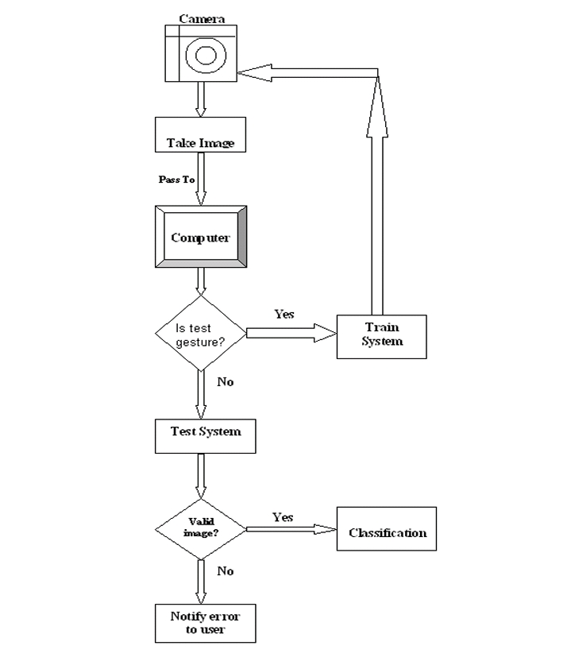

**3.2 Details Hardware & Software**

**3.2.1 Hardware Components Required:**

**1. Computer:** • A computer is needed to run the developed system.

**2. Operating System:**

• Windows 11

**3. RAM:**  
 • 8GB

**4. Processor:**  
 • I5 processor is used.

**3.2.2 Software Components Required**

* **IDE:-** An **integrated development environment** (IDE) is software for building applications that combines common developer tools into a single graphical user interface (GUI). Tools provided by an IDE include a text editor, a project editor, a tool bar, and an output viewer. Examples of IDEs include NetBeans, Eclipse, IntelliJ, and Visual Studio.
* **PYTHON:-** Python is a computer programming language often used to build websites and software, automate tasks, and conduct data analysis. Python is a general-purpose language, meaning it can be used to create a variety of different programs and isn't specialized for any specific problems
* **LIBRARIES :- Python libraries like NumPy, OpenCV, media pipe, TensorFlow**

**3.3 Methodology**

* The overview of the hand gesture recognition system consists of the following stages.
* The first stage is the hand gesture image capture stage where the images are taken using digital camera under different conditions such as scaling, translation and rotation.
* The second stage is a pre-processor stage in which edge detection, smoothing, and other filtering processes occur.
* In the next stage, the features of the images of hand gesture are extracted using two methods, namely, hand contour and complex moments.
* The last stage is the classification using Artificial Neural Network (ANN), where the recognition rate is calculated for both hand contour-based ANN and complex moments-based ANN and comparison is carried out.

**3.4 Working**

* A gesture recognition system starts with a camera pointed at a specific three-dimensional zone, capturing frame-by-frame images of hand positions and motions.

* Those images are analyzed in real time by computer vision and machine learning technologies, which translate the hand motions into commands, based on a predetermined library of signs.
* Commands generated by the gesture recognition software become just another type of input, similar to turning a dial, pressing a button or touching a screen.

# Chapter 4

**4.1Outputs**

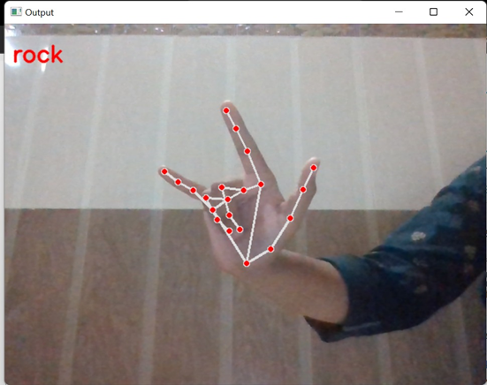

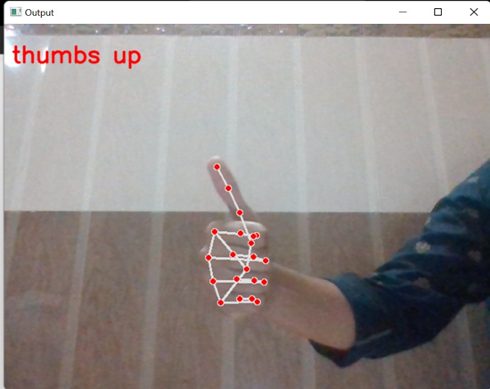

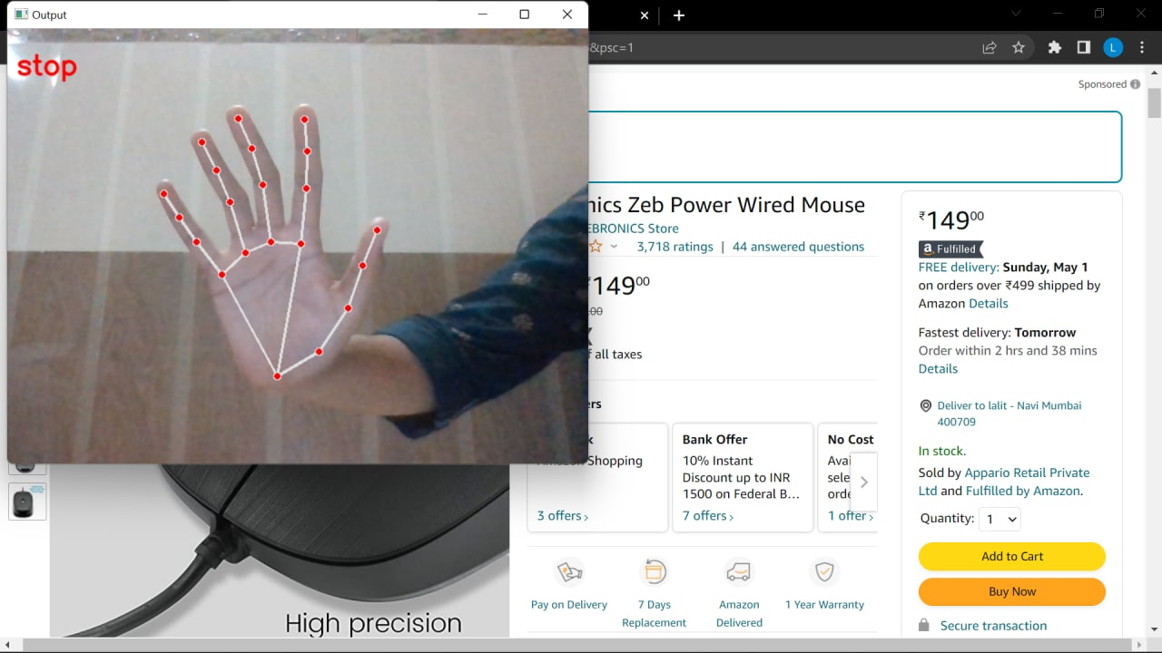

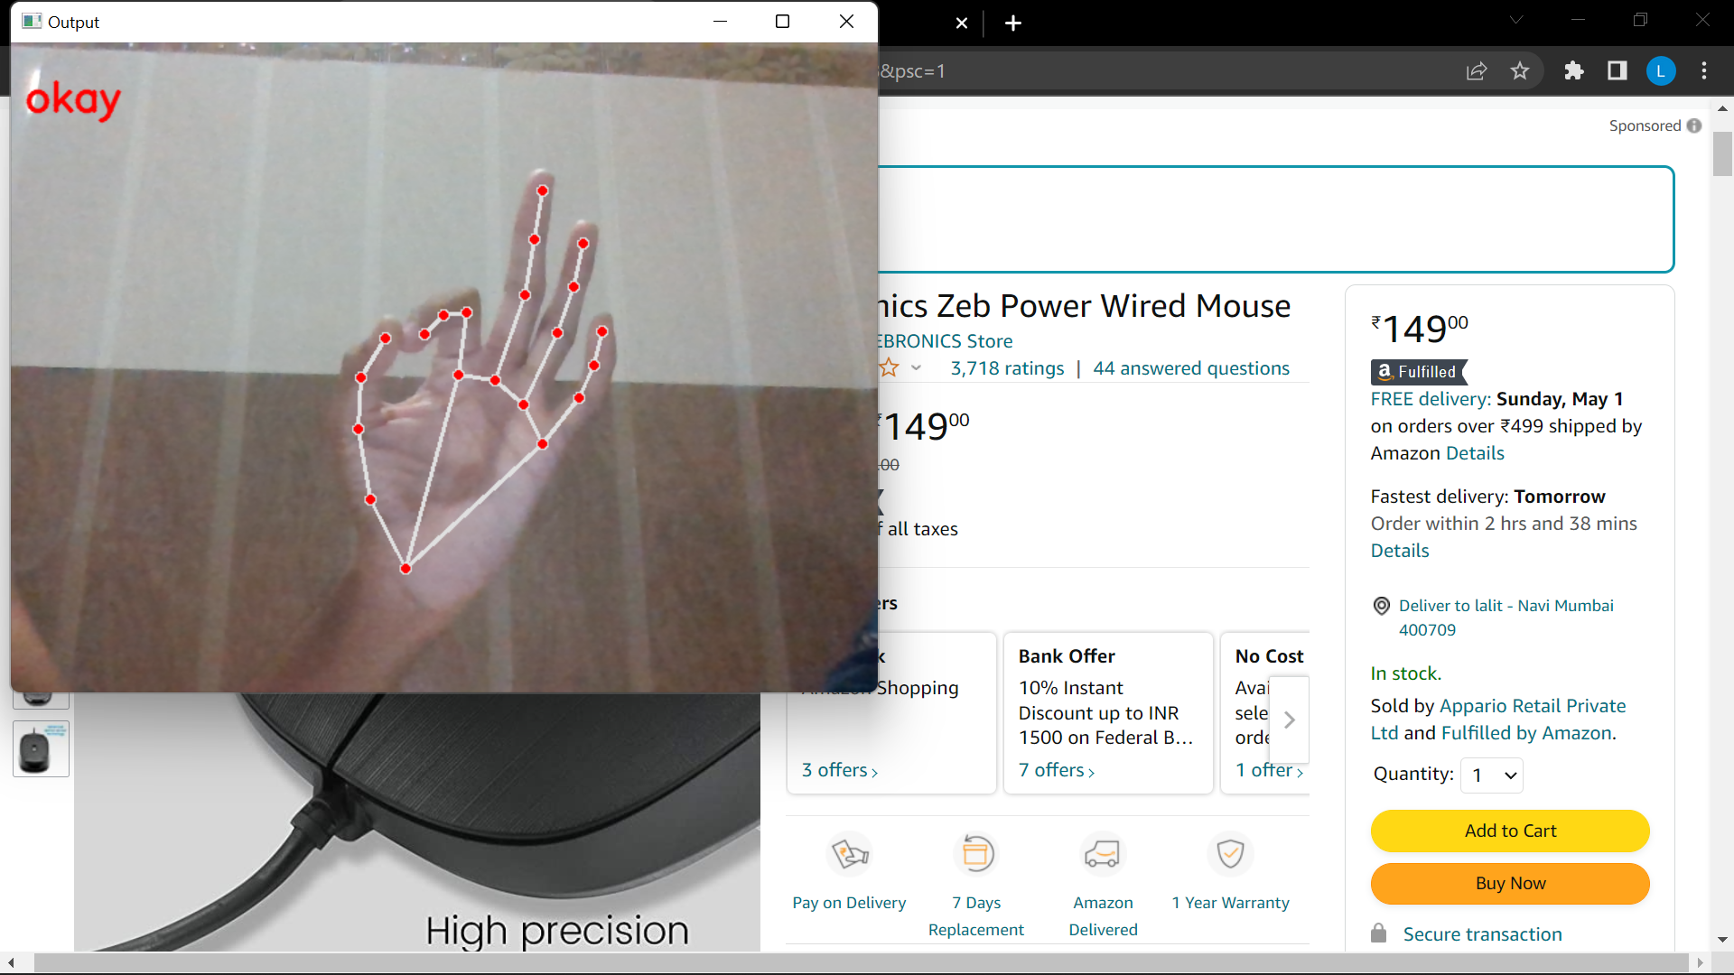

# Chapter 5

# Result

* To recognize hand movement and gesture and interpret it to natural language.
* The scope of this project is to build a real-time gesture classification system that can automatically detect gestures in natural lighting conditions.
* In order to accomplish this objective, a real-time gesture-based system is developed to identify gestures.  
  This system will work as one of the futuristic of Artificial Intelligence and computer vision with the user interface.
* It creates a method to recognize hand gestures based on different parameters.
* Priority of this system is to be simple, easy, and user-friendly Without making any special hardware. All computation will occur on a single PC or workstation.  
  Only special hardware will use to digitize the image (Digital Camera)

# Chapter 6

**Conclusions and Future Scope**

In this modern world, where technologies is at the peak, there are many facilities available for offering input to any applications running on the computer systems, some of the inputs can be offered using physical touch and some of them without using physical touch (like speech, hand gestures, head gestures etc.).

Using hand gestures many users can handle applications from distance without even touching it. But there are many applications which cannot be controlled using hand gestures as an input.

This technique can be very helpful for physically challenged people because they can define the gesture according to their need.

The present system which we have implemented although seems to be user friendly as compared to modern device or command based system but it is less robust in detection and recognition as we have seen in the previous step.

We need to improve our system and try to build more robust algorithm for both recognition and detection even in the cluttered background and a normal lighting condition.

However we can use this system to control applications like power point presentation, games, media player, windows picture manager etc.

**REFERENCES**

1. Shukla, J., & Dwivedi, A. (2014). *A Method for Hand Gesture Recognition.* doi:10.1109/csnt.2014.189
2. . Sun, J.-H., Ji, T.-T., Zhang, S.-B., Yang, J.-K., & Ji, G.-R. (2018). *Research on the Hand Gesture Recognition Based on Deep Learning. 2018*
3. Hussain, S., Saxena, R., Han, X., Khan, J. A., & Shin, H. (2017). *Hand gesture recognition using deep learning*